PROJECT REPORT
Flashcard Learning System in C Programming

1. Title of the Project
Flashcard Learning System
Title Page
Course: Programming in C
Submitted By: __SHAGUN MER_____
Roll Number: ___590027223_____
Academic Year: 2025-26

2. Introduction
Learning and revision become easier when information is organized in compact question-answer form, similar to traditional flashcards. This project implements a digital Flashcard Learning System using the C programming language.
The system allows users to:
- Add new flashcards
- View stored flashcards
- Search flashcards by keyword
- Take a quiz mode
- Delete flashcards
- Save and load data from a file
This project demonstrates data structures, file handling, user-defined functions, pointers, and modular programming in C.

3. Objectives
- To store educational content in an organized question-answer format.
- To build a user-friendly console-based learning tool.
- To explore file handling, arrays, structs, and functions in C.
- To provide a revision and testing mode for learners.

4. Scope of the Project
The Flashcard Learning System is useful for:
- Students preparing for exams
- Teachers creating study material
- Self-learners who need quick revision tools
- Competitive exam preparation (MCQs, definitions, formulas)
Future scope includes encrypted storage, multiple users, shuffle quiz mode, and UI upgrades.

5. Software & Hardware Requirements
Category | Requirement
Programming Language | C
Compiler | GCC / Turbo C / CodeBlocks / Dev-C++
RAM | Minimum 2 GB
OS | Windows / Linux / MacOS

6. System Design
6.1 Flowchart

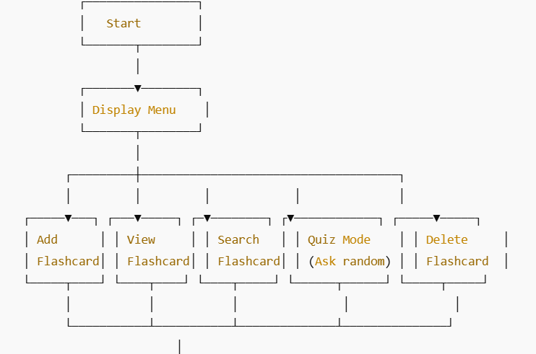

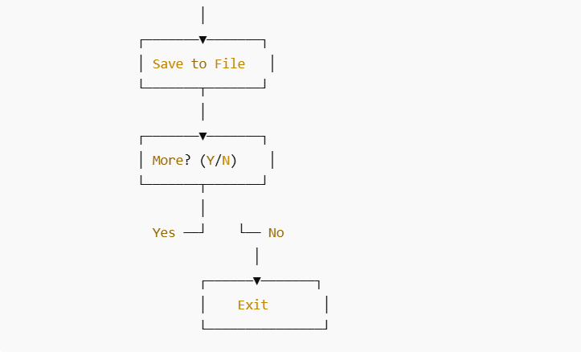
7. Program Code
#include <stdio.h>
#include <stdlib.h>
#include <string.h>
#include <time.h>

#define FILENAME "flashcards.txt"

struct Flashcard {
char question[200];
char answer[200];
};

void addFlashcard();
void viewFlashcards();
void quizMode();
void searchFlashcard();
void deleteFlashcard();
void removeNewline(char *str);

int main() {
int choice;
srand(time(NULL));

while (1) {
printf("\n====== FLASHCARD LEARNING SYSTEM ======\n");
printf("1. Add Flashcard\n");
printf("2. View Flashcards\n");
printf("3. Quiz Mode\n");
printf("4. Search Flashcard\n");
printf("5. Delete Flashcard\n");
printf("6. Exit\n");
printf("Enter your choice: ");
scanf("%d", &choice);

while(getchar()!='\n');

switch(choice) {
case 1: addFlashcard(); break;
case 2: viewFlashcards(); break;
case 3: quizMode(); break;
case 4: searchFlashcard(); break;
case 5: deleteFlashcard(); break;
case 6: printf("\nGoodbye! Keep Learning! 👋\n"); exit(0);
default: printf("\nInvalid choice, try again.\n");
}
}
return 0;
}

void removeNewline(char *str) {
str[strcspn(str, "\n")] = '\0';
}

void addFlashcard() {
FILE *fp = fopen(FILENAME, "a");
struct Flashcard f;

if (!fp) {
printf("Error opening file.\n");
return;
}

printf("\nEnter Question: ");
fgets(f.question, sizeof(f.question), stdin);

printf("Enter Answer: ");
fgets(f.answer, sizeof(f.answer), stdin);

removeNewline(f.question);
removeNewline(f.answer);

fprintf(fp, "%s|%s\n", f.question, f.answer);
fclose(fp);

printf("\nFlashcard Added Successfully!\n");
}

void viewFlashcards() {
FILE *fp = fopen(FILENAME, "r");
char line[400];
int count = 1;

if (!fp) {
printf("No flashcards available.\n");
return;
}

printf("\n------ FLASHCARD LIST ------\n");
while (fgets(line, sizeof(line), fp)) {
char *q = strtok(line, "|");
char *a = strtok(NULL, "|");

if(q && a)
printf("\n%d) Q: %s\n A: %s", count++, q, a);
}

fclose(fp);
}

void quizMode() {
FILE *fp = fopen(FILENAME, "r");
struct Flashcard cards[100];
char line[400], userAnswer[200];
int count = 0;

if (!fp) {
printf("\nNo flashcards available.\n");
return;
}

while (fgets(line, sizeof(line), fp) && count < 100) {
char *q = strtok(line, "|");
char *a = strtok(NULL, "|");

if(q && a) {
strcpy(cards[count].question, q);
strcpy(cards[count].answer, a);
removeNewline(cards[count].answer);
count++;
}
}
fclose(fp);

if (count == 0) {
printf("\nNo flashcards to quiz.\n");
return;
}

int randomIndex = rand() % count;
printf("\nQUIZ TIME!\n");
printf("Question: %s\n", cards[randomIndex].question);

printf("Your Answer: ");
fgets(userAnswer, sizeof(userAnswer), stdin);
removeNewline(userAnswer);

if (strcmp(userAnswer, cards[randomIndex].answer) == 0) {
printf("\nCorrect! 🎉\n");
} else {
printf("\nIncorrect \nCorrect Answer: %s\n", cards[randomIndex].answer);
}
}

void searchFlashcard() {
FILE *fp = fopen(FILENAME, "r");
char keyword[100], line[400];
int found = 0;

if (!fp) {
printf("\nFile not accessible.\n");
return;
}

printf("\nEnter keyword to search: ");
fgets(keyword, sizeof(keyword), stdin);
removeNewline(keyword);

while (fgets(line, sizeof(line), fp)) {
if (strstr(line, keyword)) {
printf("\nMatch Found:\n%s", line);
found = 1;
}
}

if (!found) printf("\nNo matching flashcard found.\n");

fclose(fp);
}

void deleteFlashcard() {
FILE *fp = fopen(FILENAME, "r");
FILE *temp = fopen("temp.txt", "w");
char keyword[100], line[400];
int deleted = 0;

if (!fp || !temp) {
printf("\nError accessing files.\n");
return;
}

printf("\nEnter keyword of flashcard to delete: ");
fgets(keyword, sizeof(keyword), stdin);
removeNewline(keyword);

while (fgets(line, sizeof(line), fp)) {
if (strstr(line, keyword)) {
deleted = 1;
} else {
fputs(line, temp);
}
}

fclose(fp);
fclose(temp);
remove(FILENAME);
rename("temp.txt", FILENAME);

if (deleted)
printf("\nFlashcard Deleted Successfully.\n");
else
printf("\nNo matching flashcard found.\n");
}

8. Sample Output Screenshots
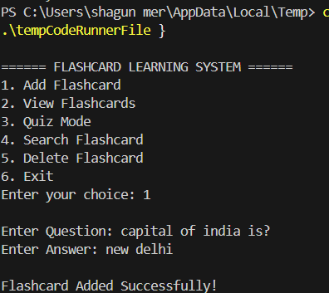
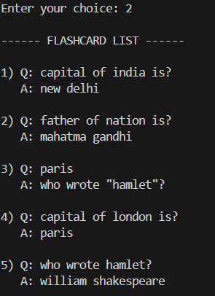

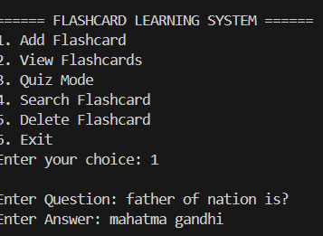
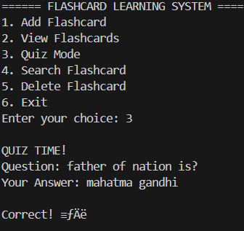
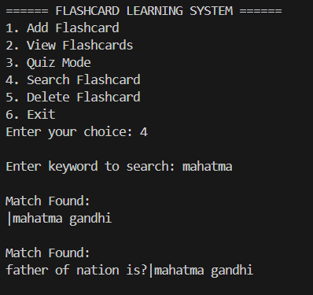
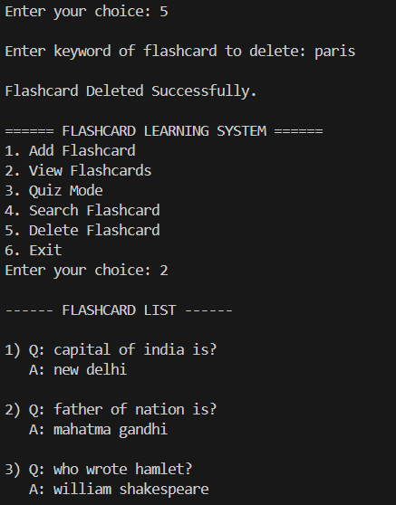
9. Testing & Validation
Test Case | Input | Expected Output | Result
Adding flashcard | Question + Answer | "Saved Successfully" | Pass
Searching keyword | "Math" | Returns related flashcards | Pass
Quiz Mode | User Answers | Shows correct/incorrect feedback | Pass

10. Applications
- Revision tool for school/college students
- Vocabulary learning
- Language flashcards
- Coding concept memory system
- Exam preparation

11. Advantages
- Simple and easy to use
- Data remains saved between sessions
- Provides revision and testing modes
- Portable and storage-efficient

12. Limitations
- Console-based interface
- No data encryption
- No user accounts or progress tracking

13. Future Enhancements
- Export to PDF
- Shuffle mode and timer quizzes
- GUI using GTK or Web-based extension
- Cloud storage sync

14. Conclusion
This project successfully implements a file-based Flashcard Learning System using C. It demonstrates the practical application of fundamental programming concepts such as file handling, arrays, structures, loops, pointers, and user-defined functions. The system helps learners revise and test knowledge interactively.

